An API (Application Programming Interface) is a mechanism that allows different software systems to communicate with each other.
A simple way to explain it to students is:
An API is like a waiter in a restaurant.
You (the customer) make a request → the waiter takes the request to the kitchen → the kitchen processes it → the waiter brings the result back.
In digital business, APIs allow companies to use, share, combine, and commercialise digital capabilities without having to build everything themselves.

1. API as a Business Model
What does it mean?
Traditionally, a company might build a complete software application and sell it directly to customers.
With an API-based business model, a company exposes some of its capabilities through APIs so that other companies can integrate them into their own applications.
For example:
A company does not need to build its own payment system.
It can integrate a payment API provided by a payment company.
Simple example: Online shopping
Imagine a student creates an online clothing store.
The store needs:
- Product catalogue
- Shopping cart
- Payment
- Delivery
- Email notifications
- Maps/location
- Customer analytics
The student could build everything from scratch—but that would take a lot of time.
Instead, the application can use APIs:
Online Store
→ Payment API
→ Delivery API
→ Maps API
→ Email API
→ Analytics API
The APIs become the building blocks of the digital business.

Real-world example: Stripe
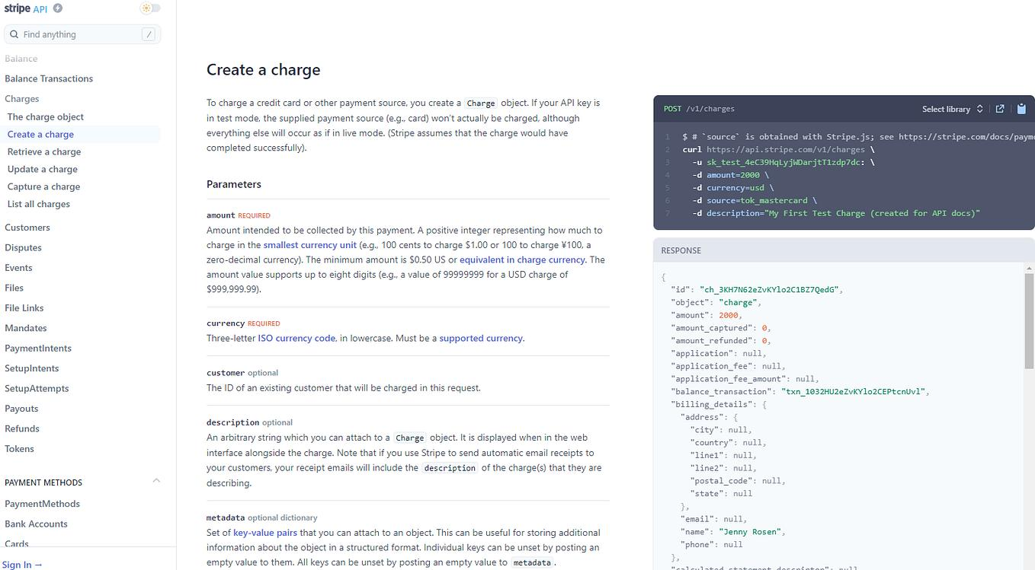
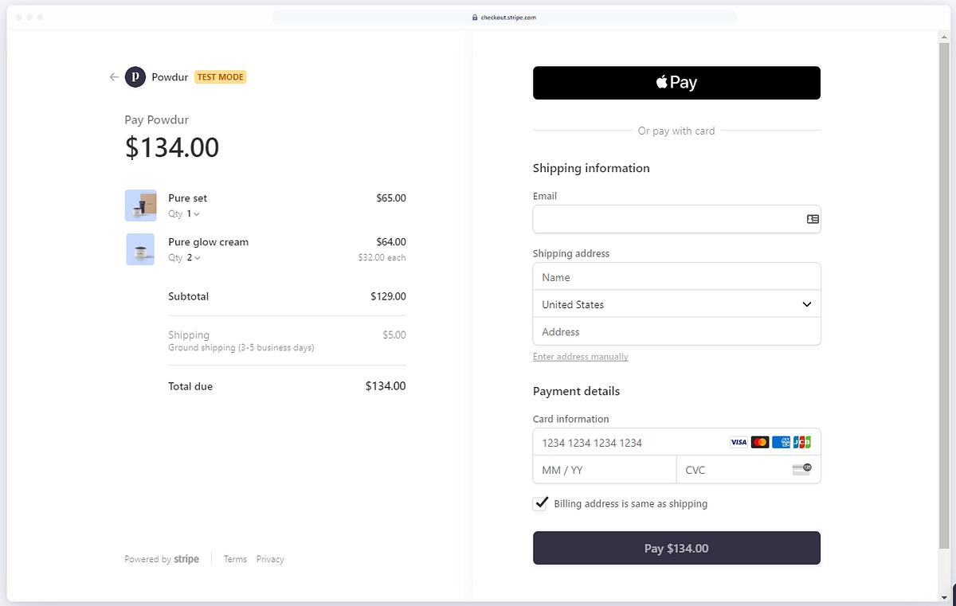
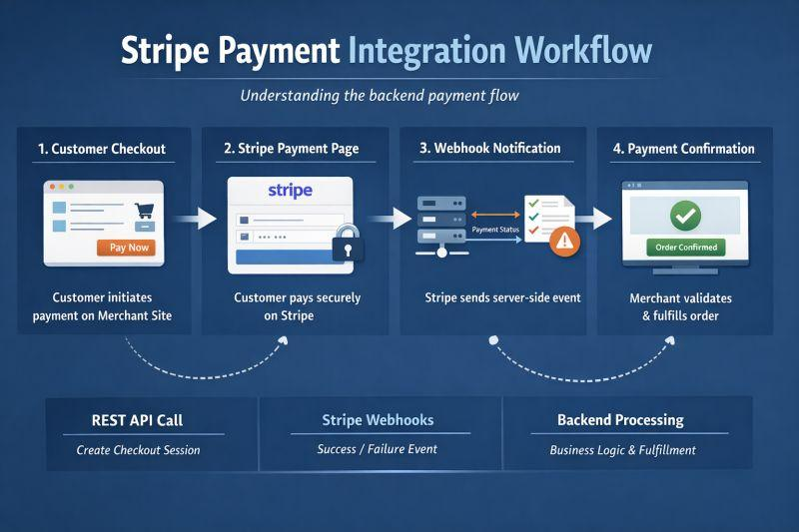

Stripe provides payment-related technology that businesses can integrate into their websites and applications.

For example:
Customer
↓
Online shopping website
↓
Stripe API
↓
Payment processing
Instead of the online store developing an entire payment infrastructure itself, it can integrate payment functionality through Stripe.
Business value
The API allows the business to:
- Accept payments
- Reduce development effort
- Integrate payment functionality into its application
- Build a smoother checkout experience
Key lesson
API as a business model = "We make our digital capability available for other businesses to use."

2. API Partner Ecosystem Networks
This concept goes one step further.
A company doesn't just provide an API to one customer. It can create an ecosystem of many developers, businesses, and technology partners.
Think of it as a digital LEGO system.
The platform provides the basic LEGO blocks.
Other companies use those blocks to create new products and services.
Example: Shopify
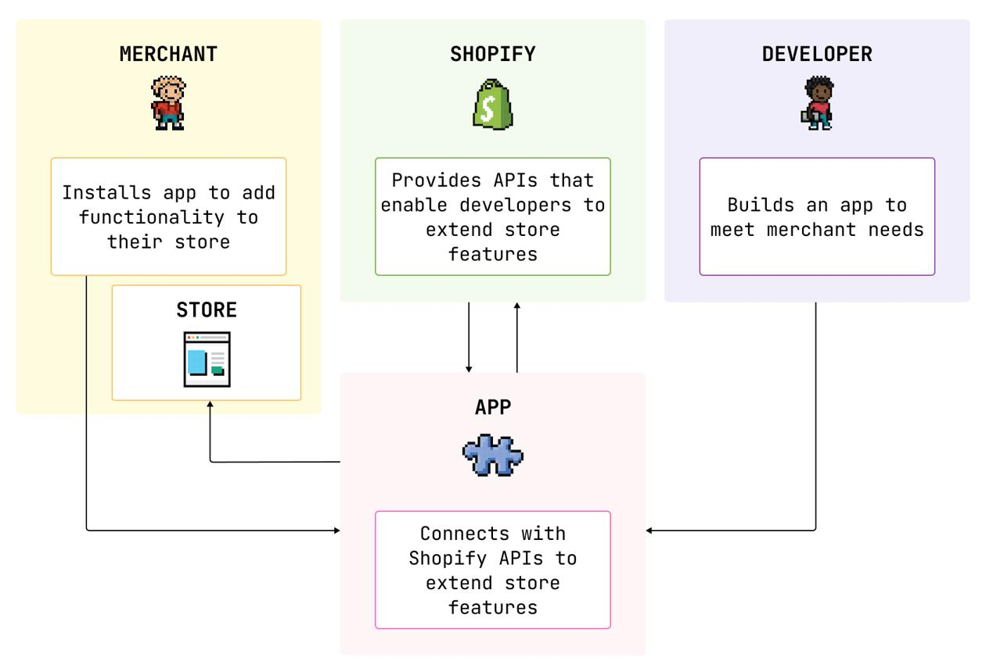
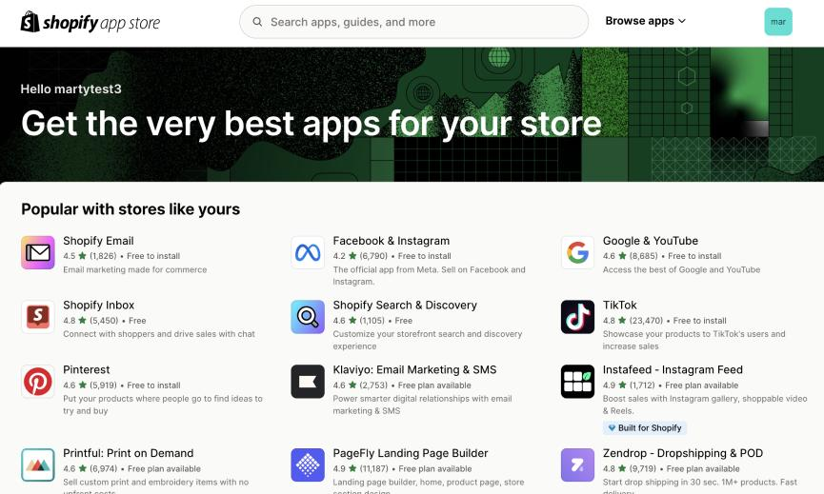
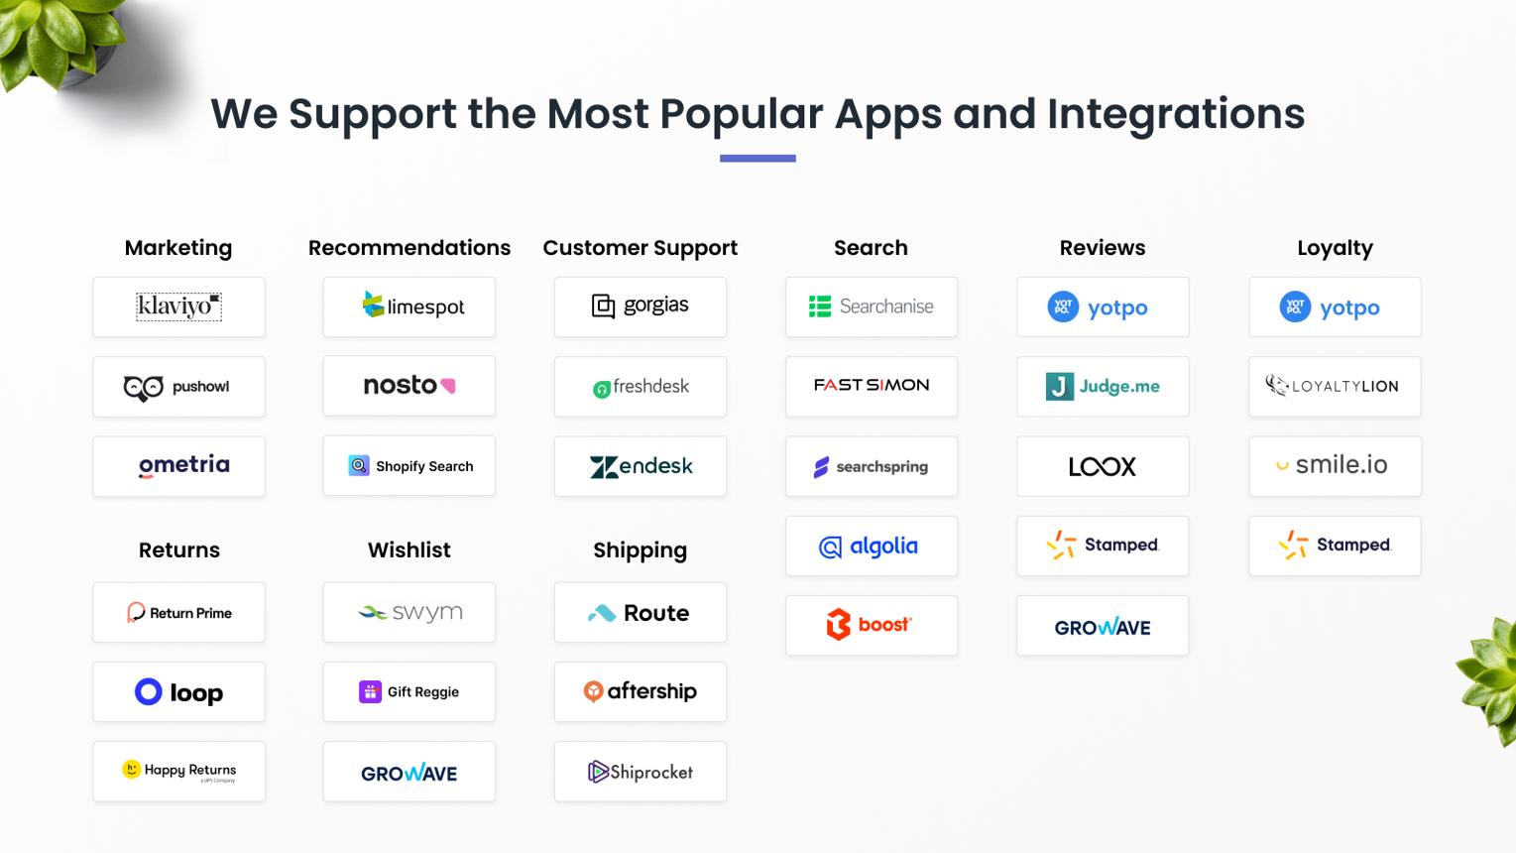
Shopify provides an e-commerce platform that can be extended through apps and integrations.
A Shopify merchant might use:
Shopify
- Accounting app
- Email marketing app
- Inventory system
- Shipping service
- Customer relationship management
- Analytics tool
- Payment service
These third-party applications can connect to Shopify through APIs and other integration mechanisms.
Example scenario
Imagine ABC Fashion Store uses Shopify.
The business wants:
- Shopify → online store
- Xero → accounting
- Mailchimp → email marketing
- Shipping provider → delivery
- Facebook/Instagram → social commerce
- Analytics → customer insights
Instead of developing every function itself, ABC Fashion Store connects different systems.
Ecosystem effect
Shopify benefits because:
More developers → more apps → more capabilities → more attractive platform → more merchants
Developers benefit because:
Shopify users → potential customers for their applications
Merchants benefit because:
More integrations → more choices and functionality
This is an API partner ecosystem.

API Ecosystem vs. Traditional Software
A useful comparison for students:
Traditional Approach | API Ecosystem Approach
Company builds everything itself | Company integrates external capabilities
Large development effort | Reuses existing services
Fewer integrations | Many integrations
Slower innovation | Faster experimentation
Closed system | More open ecosystem
Difficult to scale features | New partners can add capabilities

Example
A restaurant developing a food-delivery application could build:
Traditional approach
Own payment system + own maps + own messaging + own analytics + own delivery system
API approach:
Payment API + Google Maps API + messaging API + analytics API + delivery API
The second approach can significantly reduce the amount of functionality the restaurant needs to develop

3. Cross-Industry Co-Creation
What does it mean?
Cross-industry co-creation happens when companies from different industries combine their capabilities to create a new customer experience or business solution.
For example:
Banking + Retail + Technology
can create new digital financial services.
Or:
Healthcare + Technology + Telecommunications
can create remote healthcare services.
The important idea is:
One company does not have to possess every capability required to create the final customer value.
Example: Banking + Retail
Imagine a customer buys a laptop from an online electronics retailer.
The retailer could integrate a financial services API.
The process might be:
Customer
↓
Online Retailer
↓
Bank/FinTech API
↓
Credit/Payment service
↓
Purchase completed
The retailer provides the product.
The financial institution provides financial/payment capabilities.
The technology platform connects them.
Value created
Retailer:
- Easier checkout
- Additional payment options
- Potentially higher conversion
Bank/FinTech:
- Access to potential customers
Customer:
- Convenient payment/financing experience
This is cross-industry value creation.

Example: Google Maps APIs + Other Industries
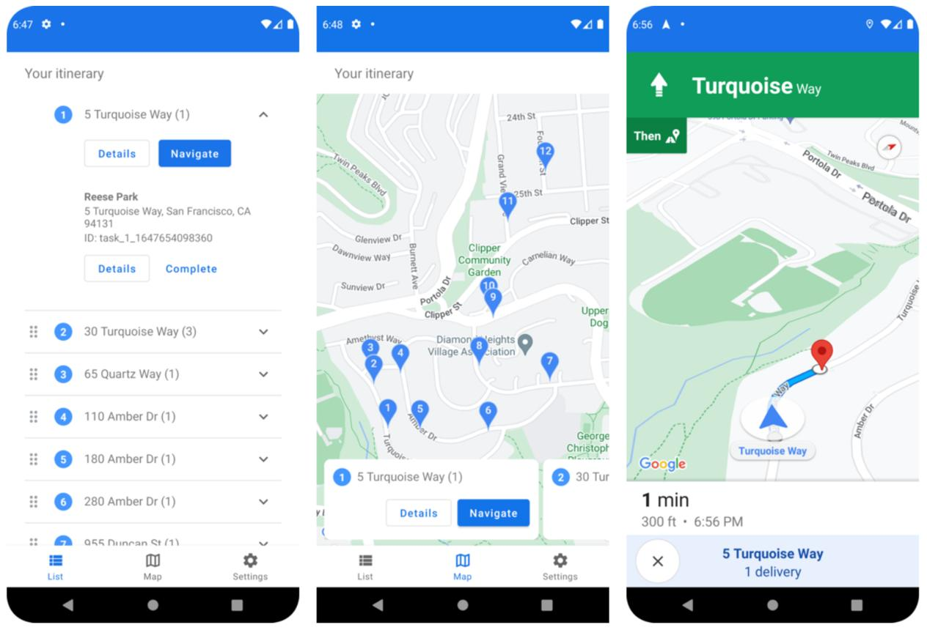
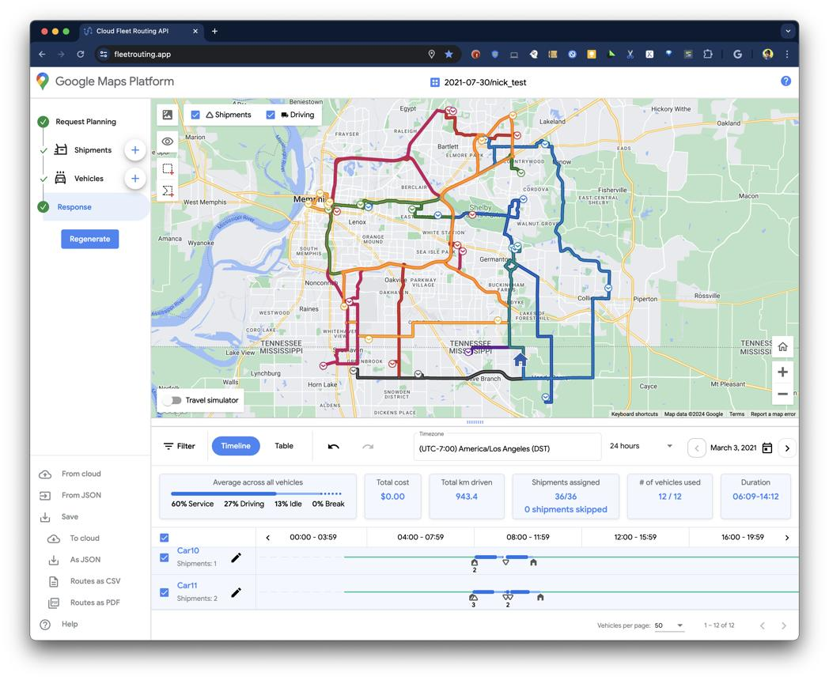
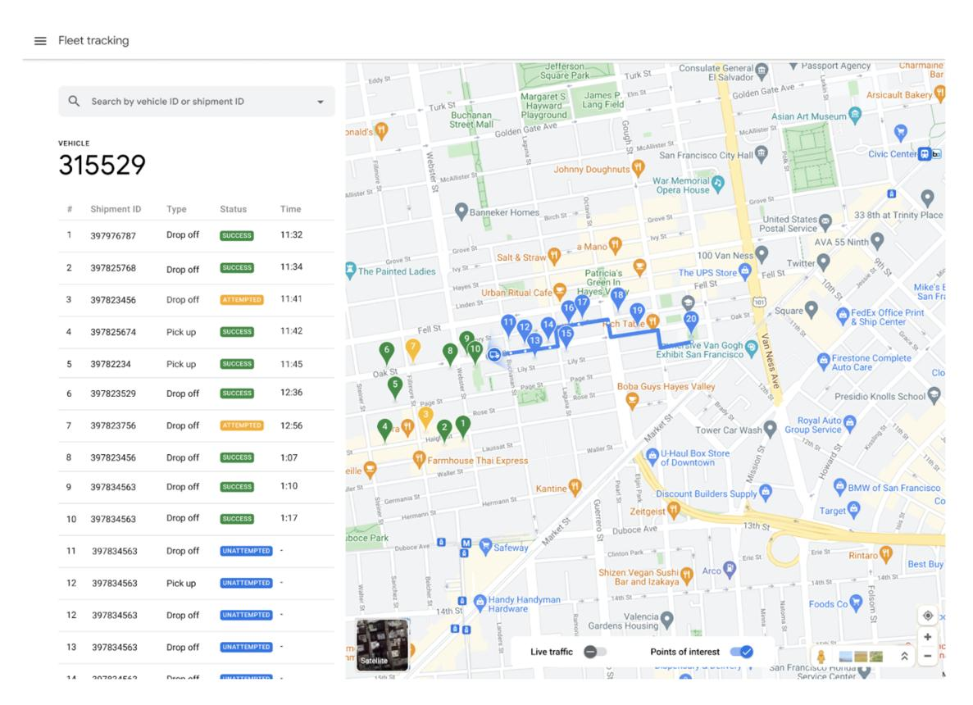
Google provides mapping and location technologies that developers can integrate into applications.
Consider a food delivery application.
The food delivery company does not need to create its own global mapping infrastructure.
It can integrate mapping/location functionality.
Food delivery process
Customer enters address
↓
Map/location API identifies location
↓
Restaurant location is displayed
↓
Delivery route is calculated
↓
Driver navigates to customer
↓
Customer tracks delivery
A mapping capability originally developed as a technology service can therefore become part of another industry's customer experience.
Cross-industry connection
Technology

Restaurant

Logistics
=
Food delivery ecosystem

Communication & Support APIs
APIs can also provide communication capabilities.
Examples include:
- SMS
- WhatsApp messaging
- Email
- Video
- Voice calls
- Customer support

Example: Twilio
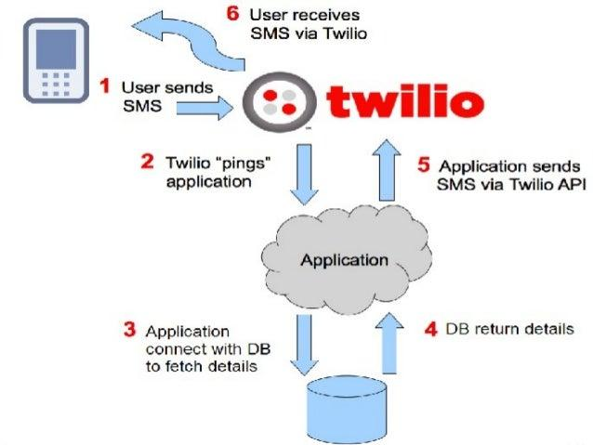
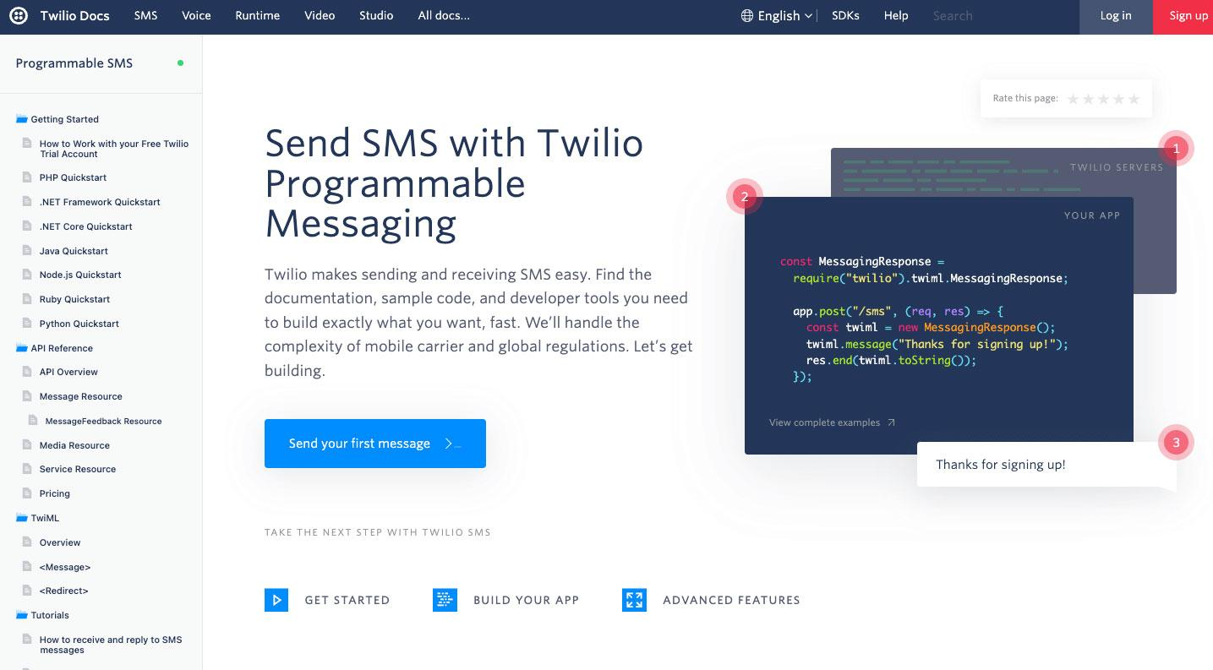
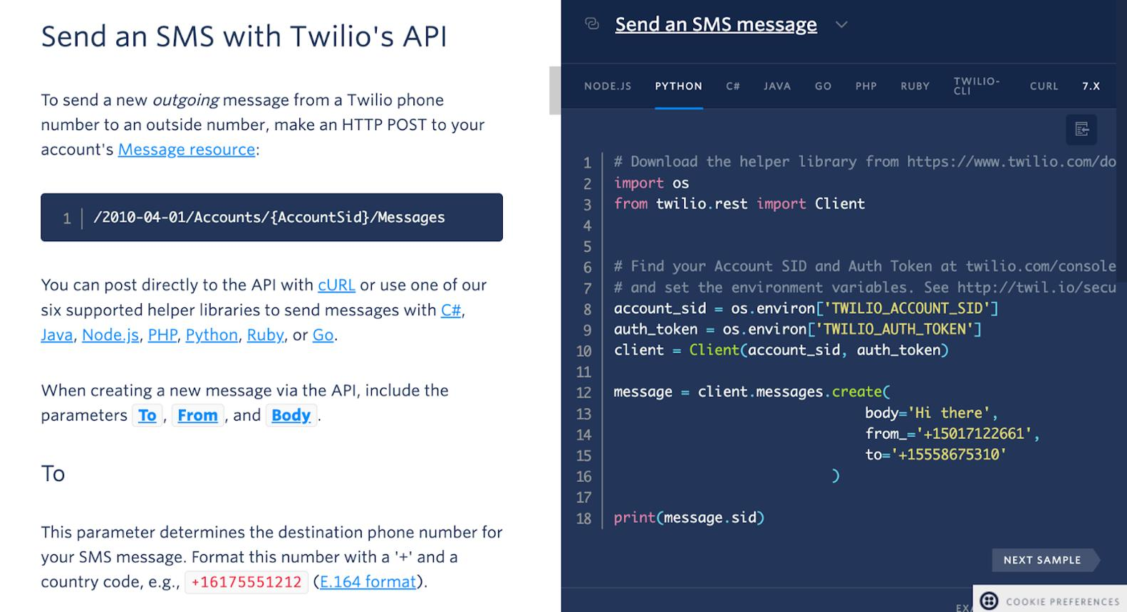
Twilio provides communication APIs that developers can integrate into applications.
Imagine an online hotel booking system.
A customer books a room.
The system could trigger:
Booking completed
↓
API
↓
SMS confirmation
↓
Customer receives message
The hotel does not necessarily need to build its own global SMS infrastructure.

4. Ecosystem Governance
This is one of the most important concepts in the slide.
If a company opens its APIs to thousands of partners, it needs rules.
Otherwise, the ecosystem can become unsafe or difficult to manage.
Ecosystem governance means deciding:
- Who can access the API?
- What data can they access?
- What can they do with the data?
- How is access authenticated?
- How is data protected?
- How much does API usage cost?
- What happens if an API is abused?
- What standards must partners follow?

API Authentication
Imagine an application wants to use a company's API.
The API provider needs to know:
"Who are you, and are you authorised to access this service?"
Common mechanisms include:
- API keys
- OAuth
- Access tokens
- Authentication credentials
Example
A student develops:
MyFoodApp
MyFoodApp wants to access a payment API.
The payment provider gives MyFoodApp credentials.
The application sends authorised requests.
The API verifies the request.
Then the API responds.
Simplified process
MyFoodApp
→ Authentication
→ API request
→ API verifies credentials
→ API processes request
→ Response

Data Compliance
Another governance issue is data protection.
Imagine a healthcare application sharing patient information through APIs.
The system cannot simply allow every partner to access everything.
Instead:
Partner A → only information required for its function
Partner B → different authorised information
Unauthorised application → access denied
This principle can be explained to students as:
Give users and applications only the access they actually need.
This is particularly important for sensitive information such as:
- Financial information
- Healthcare information
- Personal information
- Authentication information

